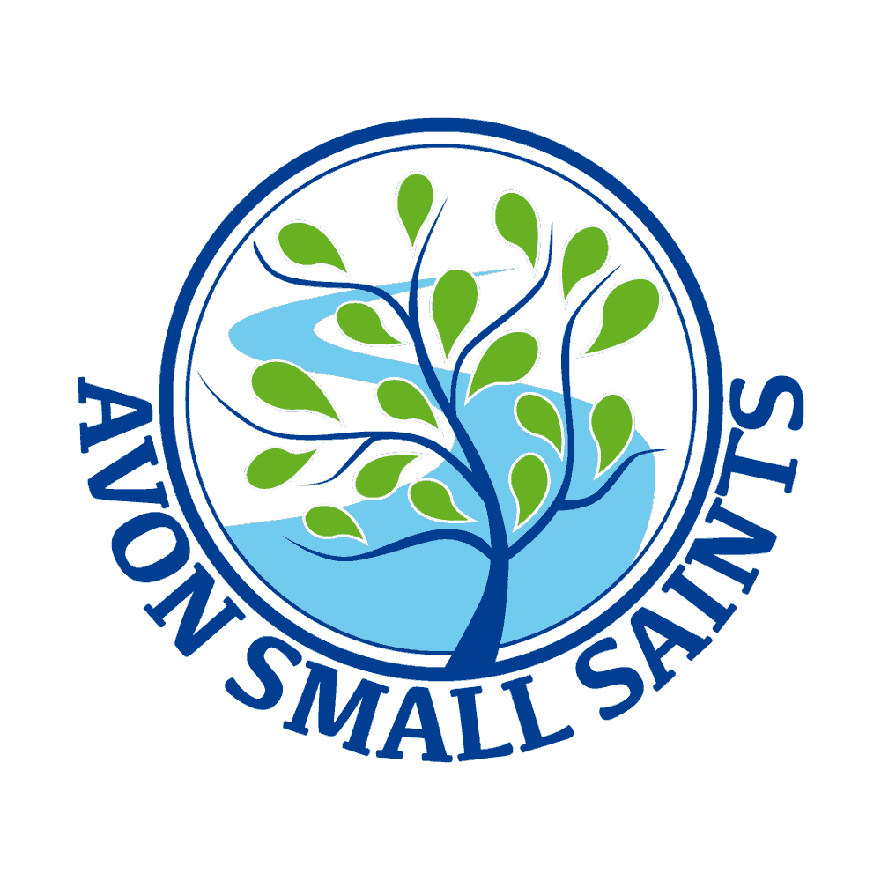 Avon Small Saints Pre-School’s
First aid Policy

Policy statement

In our setting, staff are able to take action to apply first aid treatment in the event of an accident involving a child or adult. At least one member of staff with current first aid training is on the premises or on an outing at any one time. The first aid qualification includes first aid training for infants and young children. We aim to ensure that first aid training is local authority approved and is relevant to staff caring for young children.

Procedures

The first aid kit
Our first aid kit is accessible at all times, complies with the Health and Safety (First Aid) Regulations 1981 and contains the following items:
- Triangular bandages (ideally at least one should be sterile) x 4.
- Sterile dressings:
- Small (formerly Medium No 8) x 3.
- Medium (formerly Large No 9) – HSE 1 x 3.
- Large (formerly Extra Large No 3) – HSE 2 x 3.
- Composite pack containing 20 assorted (individually-wrapped) plasters x 1.
- Sterile eye pads (with bandage or attachment) eg No 16 dressing x 2.
- Container of 6 safety pins x 1.
- Guidance card as recommended by HSE x 1.

In addition to the first aid equipment, each box should be supplied with:
- 2 pairs of disposable plastic (PVC or vinyl) gloves.
- 1 plastic disposable apron.
- A thermometer.

- The first aid box is easily accessible to adults and is kept out of the reach of children.
- No un-prescribed medication is given to children, parents or staff.
- At the time of admission to the setting, parents' written permission for emergency medical advice or treatment is sought. Parents sign and date their written approval.
- Parents sign a consent form at registration allowing staff to take their child to the nearest Accident and Emergency unit to be examined, treated or admitted as necessary on the understanding that parents have been informed and are on their way to the hospital.
- Our nominated First Aider is Ami Hay and Alice Dickety

