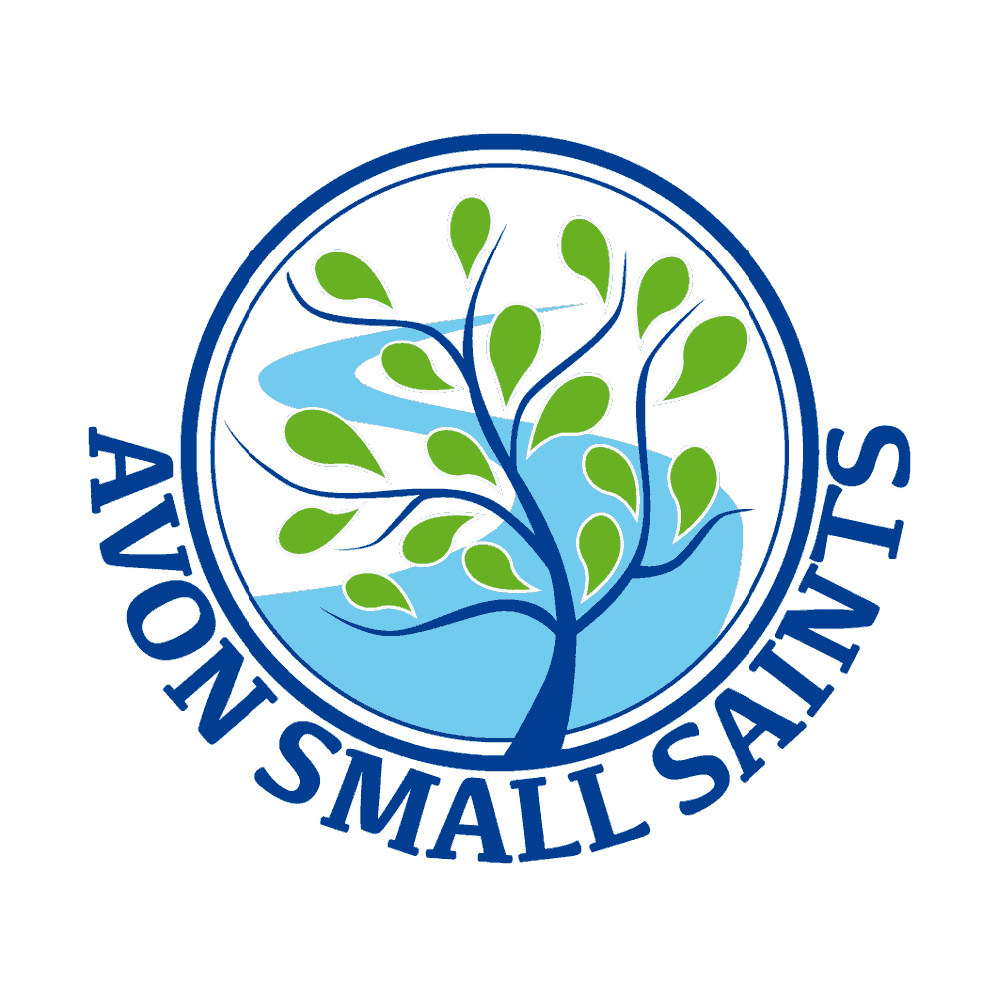 Avon Small Saints Pre-School’s
Healthy Eating Policy

Policy statement

Our provision regards snack and meal times as an important part of our day. Eating represents a social time for children and adults and helps children to learn about healthy eating. We promote healthy eating using resources and materials from the Pre-school Learning Alliance. At snack and meal times, we aim to provide nutritious food, which meets the children's individual dietary needs.

Procedures

We follow these procedures to promote healthy eating in our setting.
- Before a child starts to attend the setting, we find out from parents their children's dietary needs and preferences, including any allergies. (See the Managing Children who are Sick, Infectious or with Allergies policy.)
- We record information about each child's dietary needs in her/his registration record and parents sign the record to signify that it is correct.
- We regularly consult with parents to ensure that our records of their children's dietary needs - including any allergies - are up-to-date. Parents sign the up-dated record to signify that it is correct.
- We display current information about individual children's dietary needs discreetly in a kitchen cupboard so that all staff and volunteers are fully informed about them.
- We implement systems to ensure that children receive only food and drink that is consistent with their dietary needs and preferences as well as their parents' wishes.
- We include a variety of foods from the four main food groups:
- meat, fish and protein alternatives;
- dairy foods;
- grains, cereals and starch vegetables; and
- fruit and vegetables.
- We include foods from the diet of each of the children's cultural backgrounds, providing children with familiar foods and introducing them to new ones.
- We take care not to provide food containing nuts or nut products and are especially vigilant where we have a child who has a known allergy to nuts.
- Through discussion with parents and research reading by staff, we obtain information about the dietary rules of the religious groups to which children and their parents belong, and of vegetarians and vegans, and about food allergies. We take account of this information in the provision of food and drinks.
- We provide a vegetarian alternative on days when meat or fish are offered and make every effort to ensure Halal meat or Kosher food is available for children who require it.
- We require staff to show sensitivity in providing for children's diets and allergies. Staff do not use a child's diet or allergy as a label for the child or make a child feel singled out because of her/his diet or allergy.
- We organise meal and snack times so that they are social occasions in which children and staff participate.
- We use meal and snack times to help children to develop independence through making choices, serving food and drink and feeding themselves.
- We provide children with utensils that are appropriate for their ages and stages of development and that take account of the eating practices in their cultures.
- We have fresh drinking water constantly available for the children. We inform the children about how to obtain the water and that they can ask for water at any time during the day. Water is only permitted in water bottles from home.
- In order to protect children with food allergies, we discourage children from sharing and swapping their food with one another.

Packed lunches
We:
- encourage parents to provide sandwiches with a healthy filling, fruit, and milk based deserts such as a yoghurt.
- discourage packed lunch contents that consist largely of crisps, processed foods, sweet drinks and sweet products such as cakes or biscuits.
- All sweets and chocolate based items and fizzy drinks are not permitted. We reserve the right to return this food to the parent as a last resort
- ensure staff sit with children to eat their lunch so that the mealtime is a social occasion and to ensure a safe eating environment
- Ask parents to cut foods provided in lunchboxes to ensure they are not a choking hazard this includes grapes, sausages and other fruit and vegetables. (They need to be cut lengthways)
- Ask parents to put an ice pack or frozen drink in their child’s lunch box to keep it at a safe temperature.

Healthy Eating
A good diet is particularly important for young children as early food experiences will impact on eating patterns and habits in their adult life

Why is a healthy diet for young children so important?
- It helps to improve their concentration, learning and behaviour
- Promotes proper physical growth and development
- Builds up their strength
- Promotes resistance to infection
- Gives plenty of energy
- Minimises future health risks like iron-deficiency anaemia, obesity, Type 2 diabetes, heart disease, stroke, cancer and dental decay
- Helps them to establish healthy eating patterns and habits for life
- Promotes good oral health.

Nut Policy
Avon Small Saints Pre-school aims to practice a nut free policy although we recognise that this cannot be guaranteed. This policy serves to set out all measures to reduce the risk to those children and adults who may suffer an anaphylactic reaction if exposed to nuts to which they are sensitive.

Food Hygiene
We maintain the highest possible food hygiene standards with regard to the purchase, storage, preparation and serving of food.
We are registered as a food provider with the Wiltshire Council Environmental Health Department.
The person in charge and the person responsible for food preparation understands the principles of Hazard Analysis and Critical Control Point (HACCP) as it applies to their business. This is set out in Safer Food Better Business. The basis for this is risk assessment as is applies to the purchase, storage, preparation and serving of food to prevent growth of bacteria and food contamination.
All staff follow the guidelines of Safer Food Better Business.
All staff dealing with food have and up to date food hygiene certificate

Food Poisoning
- We notify Ofsted of any food poisoning affecting two or more children looked after on the premises as soon as is reasonably practicable, but in any event within 14 days of the incident.

