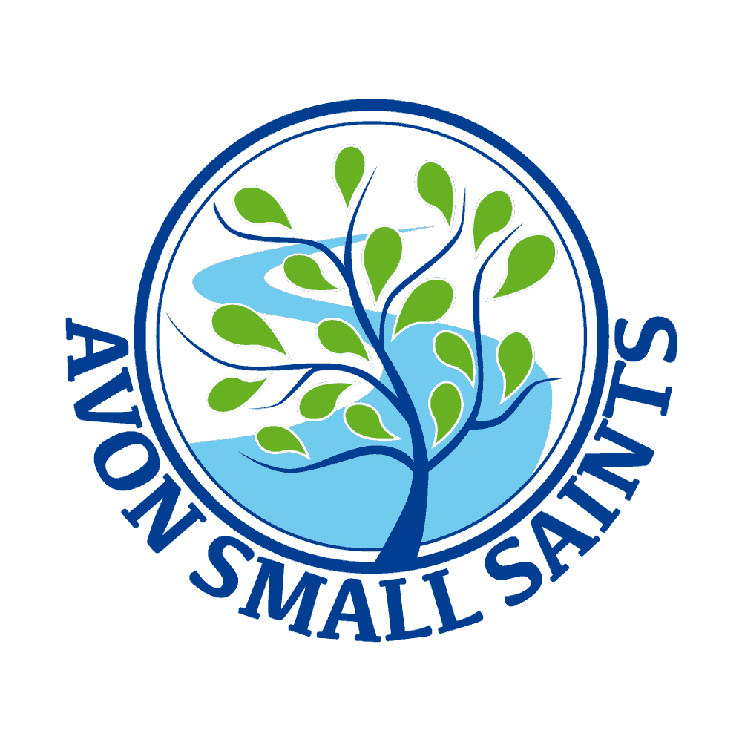 Avon Small Saints Pre-School’s
Supporting Children with Special Educational Needs and Disabilities

Policy statement

We provide an environment in which all children, including those with special educational needs and disabilities, are supported to reach their full potential.

- We have regard for the DfE Special Educational Needs Code of Practice (2014).
- We ensure our provision is inclusive to all children with special educational needs and disabilities.
- We support parents and children with special educational needs and disabilities (SEND).
- We identify the specific needs of children with special educational needs and meet those needs through a range of SEND strategies.
- We work in partnership with parents and other agencies in meeting individual children's needs.
- We monitor and review our policy, practice and provision and, if necessary, make adjustments.

Procedures

- We designate a member of staff to be the Special Educational Needs Co-ordinator (SENCO) and give her name to parents. Our SENCO is
Alice Dickety
- We ensure that the provision for children with special educational needs is the responsibility of all members of the setting.
- We ensure that our inclusive admissions practice ensures equality of access and opportunity.
- We use the graduated response system for identifying, assessing and responding to children's special educational needs.
- We work closely with parents of children with special educational needs to create and maintain a positive partnership.
- We ensure that parents are informed at all stages of the assessment, planning, provision and review of their children's education.
- We provide parents with information on sources of independent advice and support.
- We liaise with other professionals involved with children with special educational needs and their families, including transfer arrangements to other settings and schools.
- We provide a broad, balanced and differentiated curriculum for all children with special educational needs.
- We use a system of planning, implementing, monitoring, evaluating and reviewing individual educational plans (IEPs) for children with special educational needs.
- We ensure that children with special educational needs are appropriately involved at all stages of the graduated response, taking into account their levels of ability.
- We have systems in place for supporting children during the Early Years Action process (stage 2 on Continuum of Need).
- We have systems in place for working with other agencies through the Common Assessment Framework (CAF) at each stage. Early Years Action Plus (stage 3 on Continuum of Need), Statutory Assessment and the Statementing process (stage 4 on Continuum of Need).
- We use a system for keeping records of the assessment, planning, provision and review for children with special educational needs.
- We provide in-service training for parents, practitioners and volunteers.
- We raise awareness of any specialism the setting has to offer, e.g. Makaton trained staff.
- We ensure the effectiveness of our special educational needs provision by collecting information from a range of sources e.g. Individual Education Plan reviews, staff and management meetings, parental and external agency's views, inspections and complaints. This information is collated, evaluated and reviewed annually.
- We provide a complaints procedure.
- We monitor and review our policy annually.

